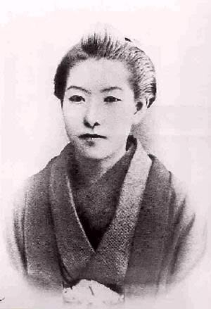
Separate Ways

Background of Higuchi Ichiyo (first major woman writer in Meiji Japan)
- Life: 1872- 1896…24 years old
- Had comfortable life in early childhood
- After father’s death family lived in poverty
- wrote novels as means of subsistence
- Died in poverty
Former Works
- Ōtsugomori (“The New Year’s Eve”)
- Takekurabe (“Child’s Play”)
- Jūsanya (“The Thirteenth Night”)
- Wakabakage (“The Shadow of Young Leaves”)
- Nigorie (Troubled Waters)
Questions:
- How do you think the author’s background influenced the story?
- What are some of the similarities and differences that Okyo and Kichizo have?
- How do you think society influenced these characters?
- On page 39, Okyo tells Kichizo “Even if I were the child of an outcast. I’d make something of myself, whether I had any parents or not…..” Later on in the story, Okyo tells Kichizo that she is going to become a mistress. Do you think she was following her own advice, or being hypocritical?
- How would you define the relationship between Okyo and Kichizo? Why do you think Kichizo felt betrayed at the end of the story?
- Do you think that Okyo is “tainted” because she is going to become a mistress?
- Do you notice any symbols in the story?
- Compared to the pieces we have read of so far, how is Okyo similar to and/or different from the Woman Who Loved Worms and Anju? Try to think about differences in time period and class systems.
- How is the way in which society treated the women in each of the stories similar or different?

